Computer Shop System

Use-Case Specification: View comment

Version 1.0

Revision History

|  |  |  |  |
| --- | --- | --- | --- |
| **Date** | **Version** | **Description** | **Author** |
| 15/12/2019 | 1.0 | details | Hoang Trung Hieu |
|  |  |  |  |
|  |  |  |  |
|  |  |  |  |

Table of Contents

1. Use-Case Name 3

1.1 Brief Description 3

2. Flow of Events 3

2.1 Basic Flow 3

2.2 Alternative Flows 3

2.2.1 < First Alternative Flow > 3

2.2.2 < Second Alternative Flow > 3

3. Special Requirements 3

3.1 < First Special Requirement > 3

4. Preconditions 3

4.1 < Precondition One > 3

5. Postconditions 3

5.1 < Postcondition One > 3

6. Extension Points 3

6.1 <Name of Extension Point> 3

Use-Case Specification: View comment

# Use-Case Name

## Brief Description

This use case helps manager to view detail information of each comment such as name, email and content. It gives an overview of comment so manager have ability to manage it.

# Flow of Events

## Basic Flow

The first step is manager must to select managing comment function in the system. Secondly, manager choose view comment button on the screen. After that, system displays list of comment from customer.

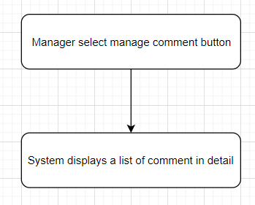

# Special Requirements

Computer store manager must know how to use management system.

# Preconditions

No preconditions

# Postconditions

No postconditions.

# Extension Points

None.